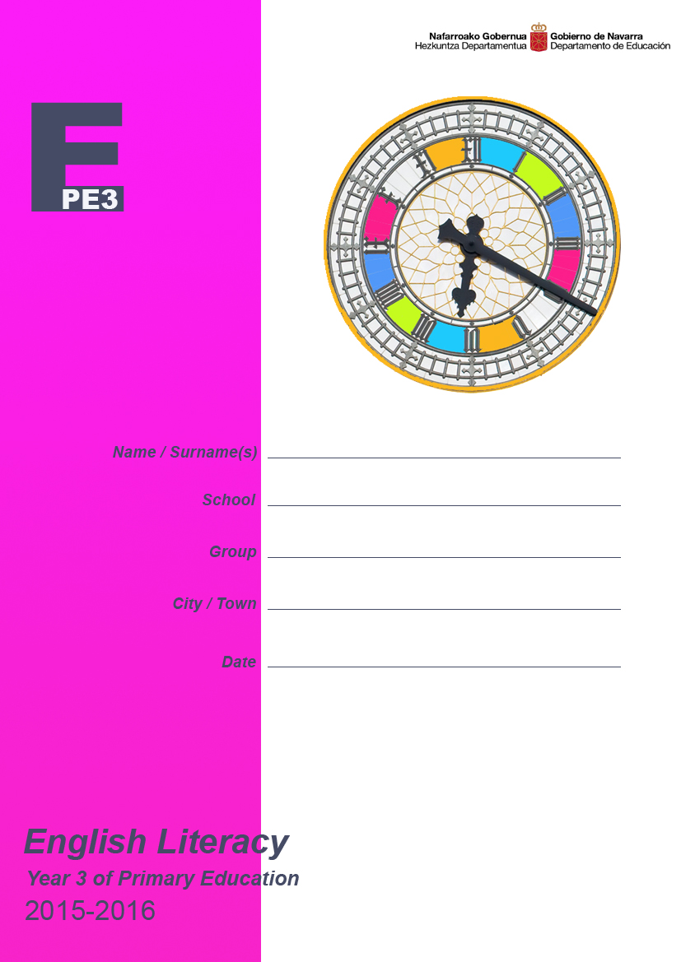
1st part

Listening

We will begin with a listening test.
First, read the first 8 questions.
Listen carefully to the recording. This recording will be played two times. After each time you will have time to answer the questions.

Reading and writing 1

You will read a text and answer some questions, and you will have to write a short description.

Reading and writing 2

Finally, you will read a text and answer some questions by choosing the best option (A, B or C) and you will have to write some sentences.

Listening

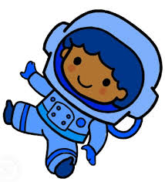
You are going to listen to a story about Billy the astronaut boy and his dog Splodge.
Please answer the questions with X in the correct box.
The first sentence is an example.

http://learnenglishkids.britishcouncil.org/es/short-stories/our-colourful-world

 |  | Yes | No
 | Billy and Splodge are in a spaceship
 | They are looking for plants | ❑ | ❑
 | The first planet is yellow | ❑ | ❑
 | There is a volcano in the yellow planet | ❑ | ❑
 | Are there any animals in the pink planet? | ❑ | ❑
 | Billy sees a blue sun, a blue desert and blue plants | ❑ | ❑
 | The green planet is very hot | ❑ | ❑
 | Are there animals in space? | ❑ | ❑
 | Do Billy and Splodge go back to planet Earth? | ❑ | ❑

Reading and writing 1

Saprunion,
the Sunflower planet

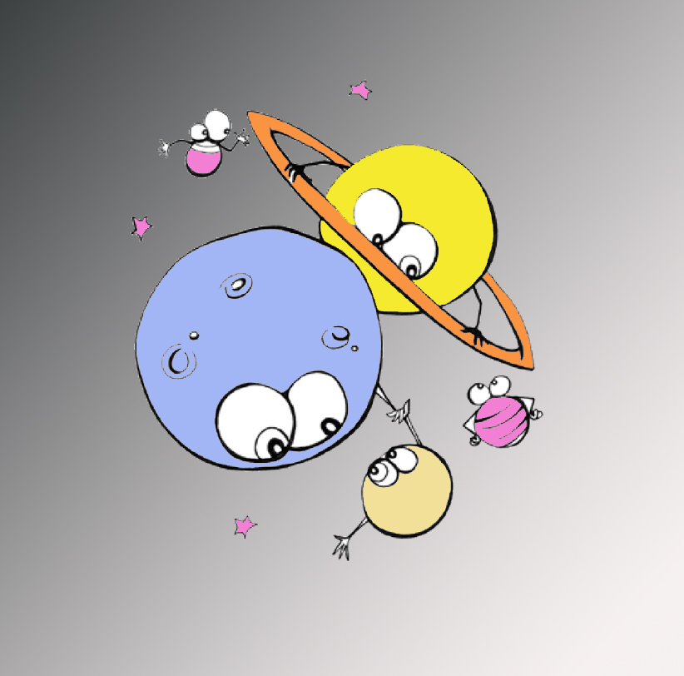
The Zorg galaxy is about 200 million kilometers from the Earth. In this galaxy there is a planet called Saprunion, which is the eighth planet in its system.
Saprunion is a giant planet, made of gas. These gases make it look yellow. It has got 5 orange rings around it, like Saturn. The planet is also known as the Sunflower planet because of these colours.

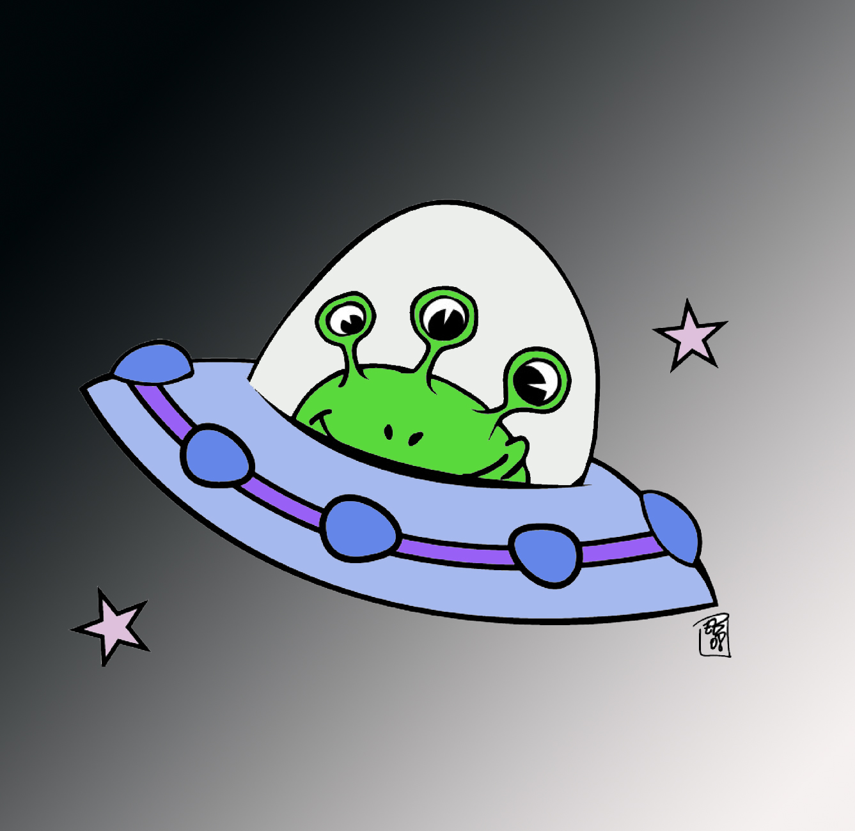
There are 7 moons orbiting Saprunion: Sap is the biggest one and Ion is the smallest. A day in Saprunion is 32 hours long and it takes 70 months to go around its sun.
The weather is very bad: it’s windy, stormy, and it's freezing cold. You can't survive in Saprunion because there is no oxygen. Saprunion has got a huge ocean of salty water but no animals live in it.

 |  | 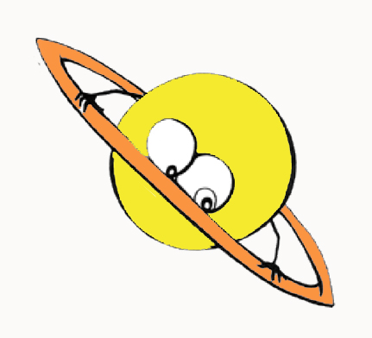 |  | 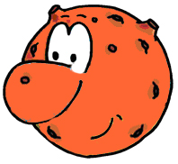
 |  | SAPRUNION |  | UGNISET
 | Where is it? | Zorg galaxy |  | Dronlet galaxy
 | How far is the galaxy from the Earth? |  |  | 130 million kilometers
 | What is the planet made of? |  |  | Rock
 | How is it? (description) |  |  | Medium size, red and brown
 | How many moons has it got? |  |  | 24 moons
 | Which is the largest moon? |  |  | Preep
 | What is the weather like? |  |  | Very hot and dry
 | You can’t live in this planet because… |  |  | … it’s full of active volcanoes
 | What has it got? |  |  | Craters and canyons
 | Its other name is.... |  |  | Inferno planet

Now write a short text about the planet Ugniset, using the information in the chart. Write as much as you can.

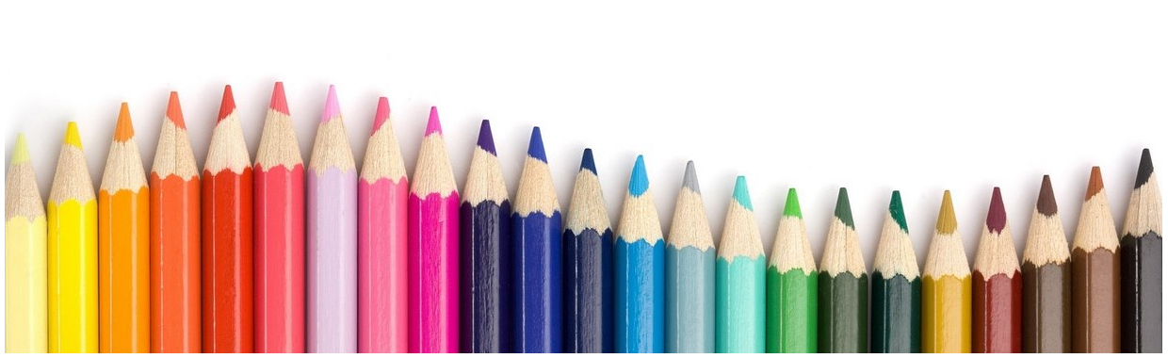
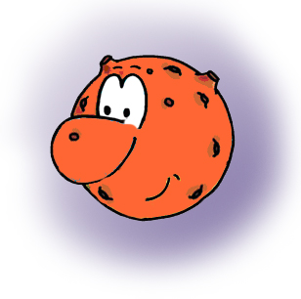

Ugniset is in the Dronlet galaxy,

.

Item |  | 0, 1, 2, or 3
 | Presentation
 | Spelling
 | Grammatical structures
 | Relevance and coherence
 | Vocabulary
Enter marks in the Educa application (items 18, 19, 20, 21 and 22).


2nd part

Reading 2
I want to be an astronaut!
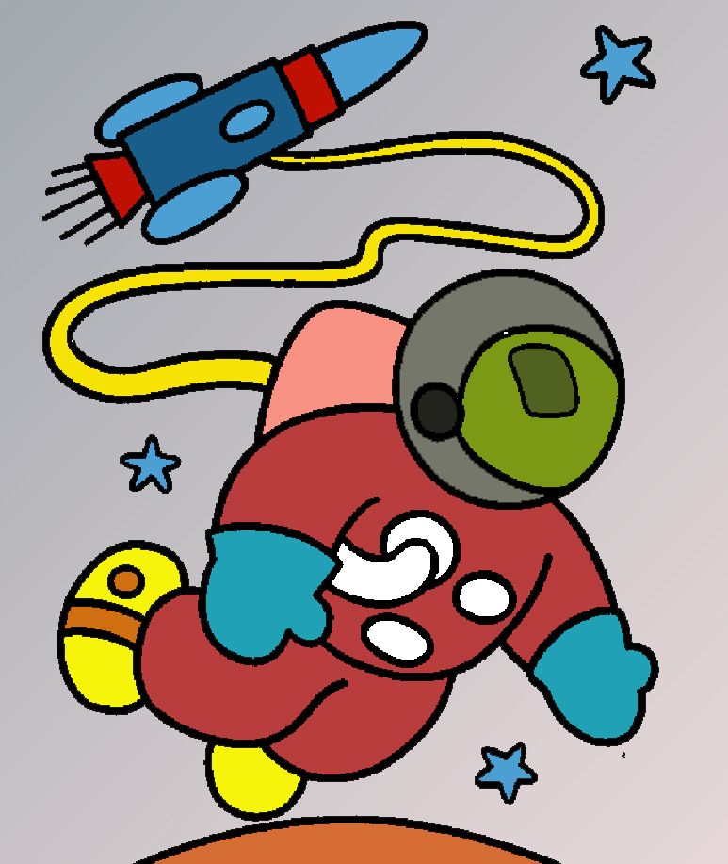
When I grow up I want to be an… astronaut! But, what do astronauts do? I looked up on the internet to learn about their everyday life.
Astronauts wake up at six o’clock in the morning and they get dressed. They usually wear comfortable clothes like T-shirts and shorts. They only have to wear their special suits when they have to go outside the spaceship to repair something.
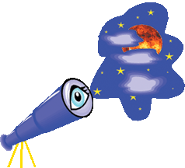
Then, it’s time for breakfast. Astronauts have a very healthy diet, but they can’t eat what you eat on Earth. They have special foods packed in a special way because everything floats around! When they finish breakfast, they brush their teeth and get ready for work.
A very important job astronauts do is taking photos using a telescope. They take photos of the Earth, planets,. stars,… and they send them back to Earth using super computers. They learn many things about space.
At midday they have lunch and in the afternoon they have free time. They can listen to music, watch T.V., write e-mails to their families… It is very important for astronauts to exercise every day, but they can’t run because they float around. They use special machines to do exercise until dinner time.
After having dinner, they go to sleep. There are no beds in the spaceship because you can’t lie down: astronauts have to sleep in special sleeping bags.
It’s a lot of work but I really really want to be an astronaut when I grow up!

- At what time does an astronaut get up?
- 7:00
- 7:30
- 6:00

- What clothes do they wear?
- T-shirt and jeans
- Shorts and T-shirt
- Pyjamas

- Why don’t astronauts wear their special suit in the ship?
- Because it’s hot inside
- Because they wear pyjamas
- Because they can breathe inside

- Astronauts wear their special suits…
- to go outside the spaceship
- to do exercise
- to parties

- Why are foods packed in a special way?
- Because they like it
- Because there is no gravity and everything floats around
- Because they can’t be recycled

- They brush their teeth…
- at six o’clock
- they don’t brush their teeth
- after breakfast

- They use a telescope to…
- find aliens
- take photos and send them back to Earth
- watch the stars

- What do astronauts do in their free time?
- Listen to music
- Play with their tablets
- Sleep

- Astronauts can’t run because…
- they are tired
- there is no space to run
- they float around

- How do they exercise?
- With an exercise bike
- With special machines
- With a ball

- Where do they sleep?
- In sleeping bags
- In beds
- They don’t sleep

- To be an astronaut is…
- easy
- difficult
- boring

Continue on next page
Now, imagine the daily routine of a teacher, and choose the correct word for each picture.

have dinner | have breakfast | teach
get up | eat a snack | go to bed
get dressed | prepare classes | go to the gym

- Before work
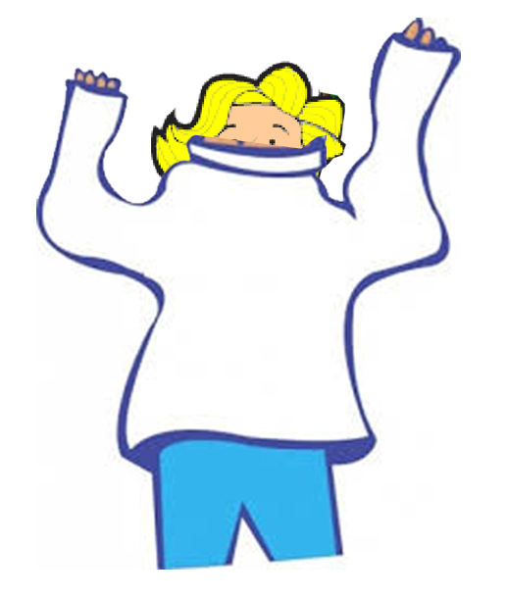
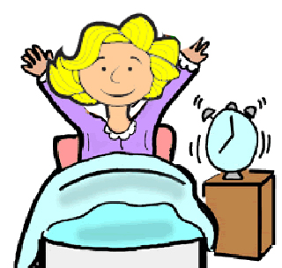
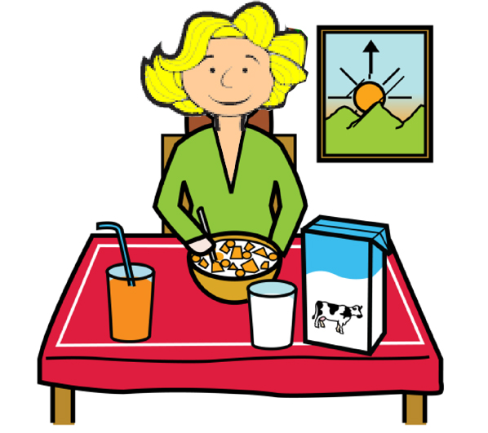

Get up

- At work
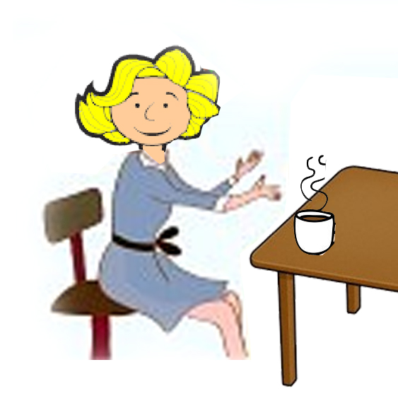
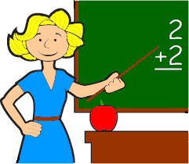
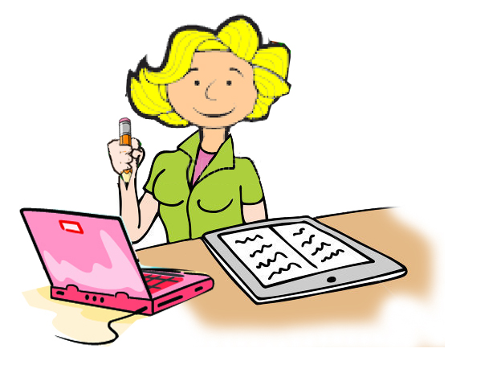

- After work
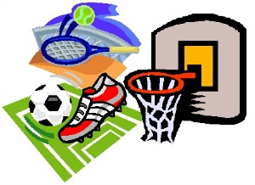
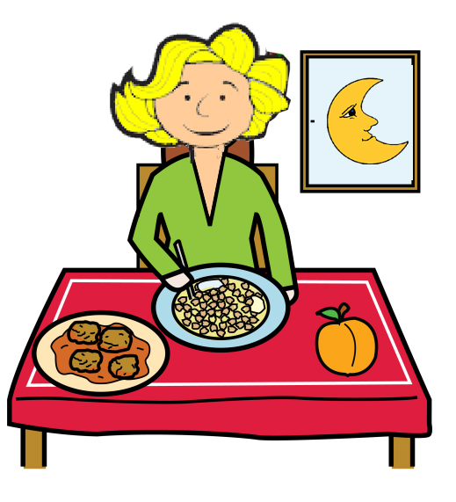
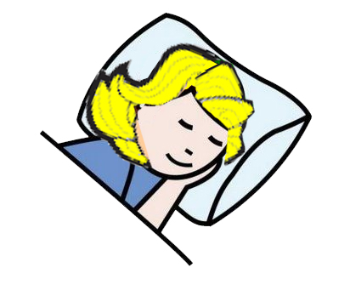

WRITING 2

- Imagine that you are Mrs. Smith, a teacher of 11 year-old pupils. Complete the next sentences.

Mrs. Smith’s day

- I am Mrs. Smith. I am a teacher at Greenwich School in London. From Monday to Friday I get up at …………………… and get ready to go to school.
- Firstly, I
- And then I

- When I arrive at school I
- And then I
- After that I

- When we finish classes I
- Later on I
- Finally
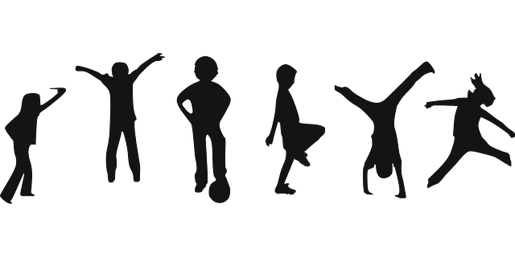

Item |  | 0, 1, 2, or 3
39. | Extension

