
EPE3
Ebaluazio eta Kalitate Atala
Sección de Evaluación y Calidad



2016/2017

Name / Surname(s):
School:
Group:
City / Town:
Date:

1st part


This first part of the test
lasts 45 minutes

English Literacy

Year 3 of Primary Education
Instructions
1st part

Listening
We will begin with a listening test. You will hear someone speaking about a situation.
- First, read the first 8 questions (2 minutes).
- Listen carefully to the recording. You will hear the recording twice.
- After each part you will have time to answer the questions.

Reading and Writing 1
You will read a text and answer some questions, and you will have to write a short description.

2nd part
Reading and Writing 2
Finally, you will read a text and answer some questions by choosing the best option (A, B or C) and you will have to write some sentences.

For each question you have to circle the right answer. For example:
Example 1. How many months are there in a year?
A. 2 months.
B. 17 months.
C. 12 months.

If you decide to change your answer, cross out (X) your first option and circle your new answer. For example:
Example 1. How many months are there in a year?
A. 2 months.
B. 17 months.
C. 12 months.

Listening – Twins’ Week




You are going to listen to a story about Kim and Kena, the twins. They live at the zoo, listen to learn about their everyday life.
Please answer the questions with an X in the correct box.
The first sentence is an example.

Listen to the audio on (only play audio script, do not visualize video):
http://learnenglishkids.britishcouncil.org/en/short-stories/twins-week

 |  | YES | NO
Example | Kim and Kena are brother and sister
 | Kim and Kena’s mother is the zookeeper
 | Are they visiting the zoo?
 | On Mondays they take a shower with the hippos
 | Does the crocodile brush his teeth on Tuesdays?
 | They play football with parrots at the park
 | They ride their bikes with the rhino at night
 | The kangaroo helps Kim and Kena with the homework
 | Can they wake up late on Sundays?
Reading 1

Tigers vs Monkeys
Next summer I’m going on a trip to India with my family. We are going to visit lots of monuments, places and markets. But the most interesting part is that we are going to some Natural National Parks in the jungle. In these parks there are many wild animals, but my two favourite ones are tigers and monkeys.

Both tigers and monkeys live in the jungle. Tigers are called “big cats”, and they are powerful carnivores. They are very dangerous and eat other animals. Tigers can live up to 20 years in zoos, but only 14 years in the wild. They can run up to 56 kilometers per hour. Tigers are not as good as monkeys climbing trees but they are great swimmers!

Monkeys are smaller animals and they eat vegetables such as fruit, flowers and leaves. They are quite fast too, but not faster than tigers. Monkeys can live many years, up to 35 in the jungle. Most of the time monkeys play and jump from tree to tree. Sometimes they even play with humans! Monkeys are similar to us: they live in big groups of different families, and live together in the same area.
And their favorite food is bananas… mine too!!

- Where can they see lots of animals in India?

……………………………………………………………………………………………….

- How long can tigers live in the jungle?

……………………………………………………………………………………………….

- Both tigers and monkeys are good at ……………………………………………….

- The fastest runner is ……………………………………………………………………

- …………………...…………………………………………… are herbivores, they eat

……………………………………………………………………………………………….

- Why are tigers dangerous? Because …………………………………………………

- Which animal can swim very well? ……………………………………………………

- I think monkeys are friendly because …………………………………………………

- What is the boy’s favourite food? ……………………………………………………..

Writing 1

Now write a short text about the OCTOPUS using what you know or the information in the card. Write as much as you can.


- Now write your text here. Be careful with the punctuation and remember the use of paragraphs and capital letters.

_________________________________________________________________________________________________________________________________________________________________________________________________________________________________________________________________________________________________________________________________________________________________________________________________________________________________________________________________________________________________________________________________________________________________________________________________________________________________________________________________________________________________________________
__________________________________________________________________________________________________________

This part is only for the teacher | Mark  0, 1, 2 or 3
Presentation
Spelling
Grammatical structures
Relevance and coherence
Vocabulary
Item 18 – Total
(Maximun punctuation: 15 points)


Don’t turn the page!!
Wait for teacher instructions.

EPE3
Ebaluazio eta Kalitate Atala
Sección de Evaluación y Calidad

2016/2017

Name / Surname(s):
School:
Group:
City / Town:
Date:

2nd part

English Literacy

Year 3 of Primary Education
This second part of the test
lasts 45 minutes

Reading 2
Do you know Chris?

This is Chris. He's got red hair and he wears glasses to read. He lives in a modern house between the library and the park. He is eleven years old and he has got a younger brother called Mark.
He starts his day at half past seven. First he gets up, goes to the bathroom and takes a shower. After that he has breakfast. He usually eats a banana, toasts and orange juice. Then, he brushes his teeth and gets dressed. Before he goes to school he has to walk his dog, Barker.

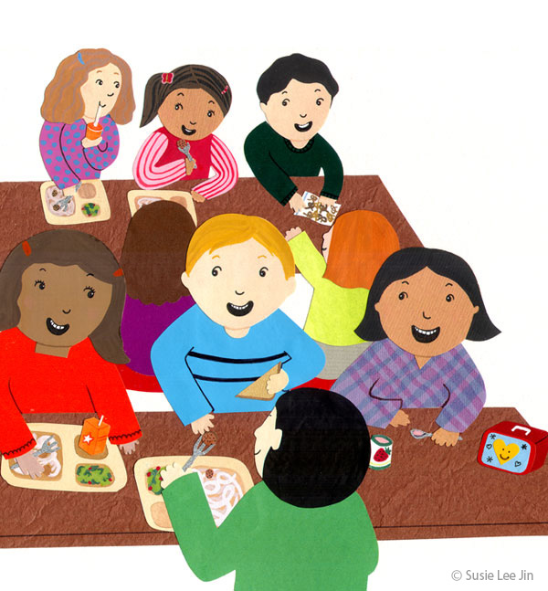
At eight o'clock he leaves home and catches the bus to school. Classes begin at half past eight. The lessons he enjoys the best are the ones where he draws and paints, but he doesn’t like Maths. He usually has lunch at the school canteen at half past one with his school friends. His best friend is George and Chris always sits next to him at lunch.
After school, at quarter past five, he goes home and eats a snack because he is always hungry. Then he does his homework and when he finishes he has time to play games with his little brother.


On Tuesdays and Thursdays he has basketball practice. His favourite sport is basketball and he loves to play with his friends. Chris wants to be a good basketball player, like Gasol!
At eight o'clock the family has dinner together. He cleans up everything after dinner. He usually watches TV for a while with his family. At about ten o'clock he brushes his teeth again, puts on his Superman pajamas and goes to bed. His parents always kiss him good night before he goes to sleep.

Chris is a very happy boy!

- At what time does Chris get up?

- 7:00
- 7:30
- 6:00

- What is the last thing Chris does before going to school?

- Walk the dog.
- Brush his teeth.
- Have breakfast.

- How does he go to school?

- By bicycle.
- On foot.
- By bus.

- What is Chris’ favourite subject?

- Maths.
- Art.
- Science.

- He takes a shower …

- in the morning.
- in the afternoon.
- before going to sleep.

- At what time does he go back home?

- At quarter past five.
- At half past seven.
- At eight o’clock.

- When he grows up, Chris wants to be …

- an artist.
- a TV actor.
- a basketball player.

- What does the family do together?

- Have lunch and watch TV.
- Have dinner and watch TV.
- Watch TV.

- After doing his homework …

- he can play basketball.
- he walks the dog.
- he can play with Mark.

- How many times does Chris brush his teeth?

- 1
- 2
- 3

- On Tuesdays and Thursdays, Chris …

- goes to the library.
- has lunch with George.
- practices his favorite sport.

- Chris helps at home by …

- cleaning after dinner.
- doing his homework.
- playing with his brother.



Continue on next page

Vocabulary: Zookeeper’s daily routines
Now, imagine the daily routine of a zookeeper, and choose the correct word for each picture.
Shower the elephants | Clean the tank | Meet visitors
Get up | Talk to the vet | Feed the animals
Brush the koalas | Play with the penguins | Have a snack

- Morning.




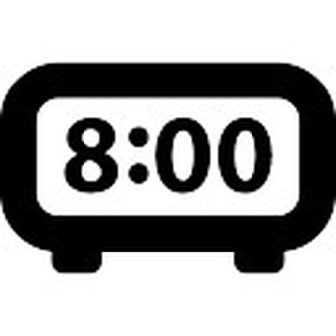
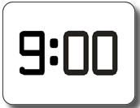
Get up

- Afternoon.

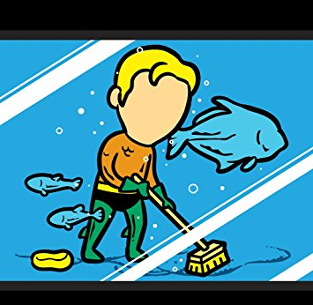



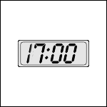

- Evening.





Writing 2
Mrs. Kimna,
the zookeeper

- This is Kim and Kena’s mother. She is the zookeeper. Complete the next sentences with her daily timetable.

- I am Mrs. Kimna, Kim and Kena’s mother. I am the zookeeper at Animalarius Zoo. Every day, I take care of the animals. My day starts at ………………………………………… in the morning.

- Firstly, I ………………………………………………………………………………
- And then I ……………………………………………………………………………..

- In the afternoon ………………………...……………………..……………………
- And then I ……………………………………………………………………………..
- After that I …………………………………………………………………………..

- When I finish that I ……………………………………………………………….
- Later on I ………………………………………………………………………………
- Finally ……………………………………………………………………………………

This part is only for the teacher | Mark
Item 34 – Sentences
(Maximun punctuation: 9 points)
Item 35 – Extension
(Maximun punctuation: 3 points)

